**VINCENT PATRICK SUARNABA** 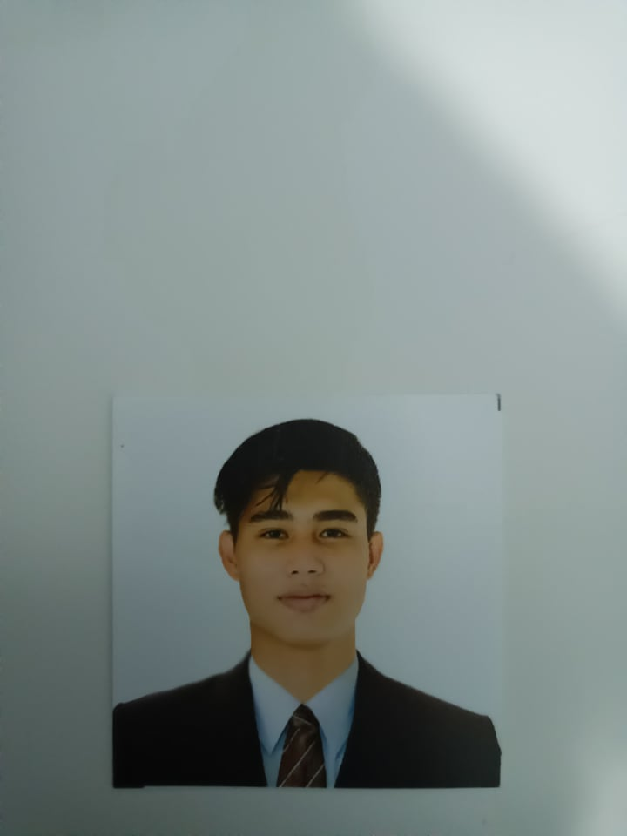

*#208 5TH ST. ROSEANN SUBD. BRGY. SAN ROQUE CAINTA, RIZAL*

Mobile # 09465361770

Email: [vincentvicerra12@gmail.com](mailto:vincentvicerra12@gmail.com)

**OBJECTIVE**

To be part of a company where I can contribute and enhance my knowledge going forward to professional growth, and self development. Eager to learn and undergo any training you have for me to be part of the success of the company.

**PERSONAL INFORMATION**

**Date of Birth:** March 4, 2000

**Birth of Place:** Kalilangan, Bukidnon

**Age:** 21 yrs. old

**Sex:**  Male

**Height:** 6’3

**Weight:**  55kg

**Civil Status:**  Single

**Religion:** Catholic

**Nationality:**  Filipino

**Name of mother:**  Marife C. Suarnaba

**Occupation:** Massage Therapist

**Name of father:**  Raymundo A. Vicerra

**Occupation:**  Supervisor

**Contact number of parents:** 09089396339

**EDUCATION**

**COLLEGE** ICCT Colleges

V.V Soliven Avenue II, Brgy. San Isidro Cainta, Rizal

Bachelor of Science in Information Technology

2021- up to present

**SENIOR HIGH SCHOOL** Cainta Senior High School

Sitio Victoria Parola St. Cainta, Rizal

Technical Vocational Livelihood (ICT)

2019- 2021

**SECONDARY** Francisco P. Felix Memorial National High School Municipal Compound Sto. Domingo, Cainta Rizal 2015-2019

**PRIMARY** Cainta Elementary School A. Bonifacio Ave. San Roque, Cainta Rizal 2007-2015

**SKILLS**

System

* Basic Computer Knowledge
* Proficient in Microsoft Office Applications

Leadership

* A team player, craven, honest

**REFERENCES**

**Roshan B. Rivera**

Nurse Training and Development Assistant

Marikina Valley Medical Center

09380851379

I hereby certify that all forgoing information given are true and correct to the best of my knowledge.

**VINCENT PATRICK SUARNABA**

**- Applicant-**